THE GRISLY CLAY

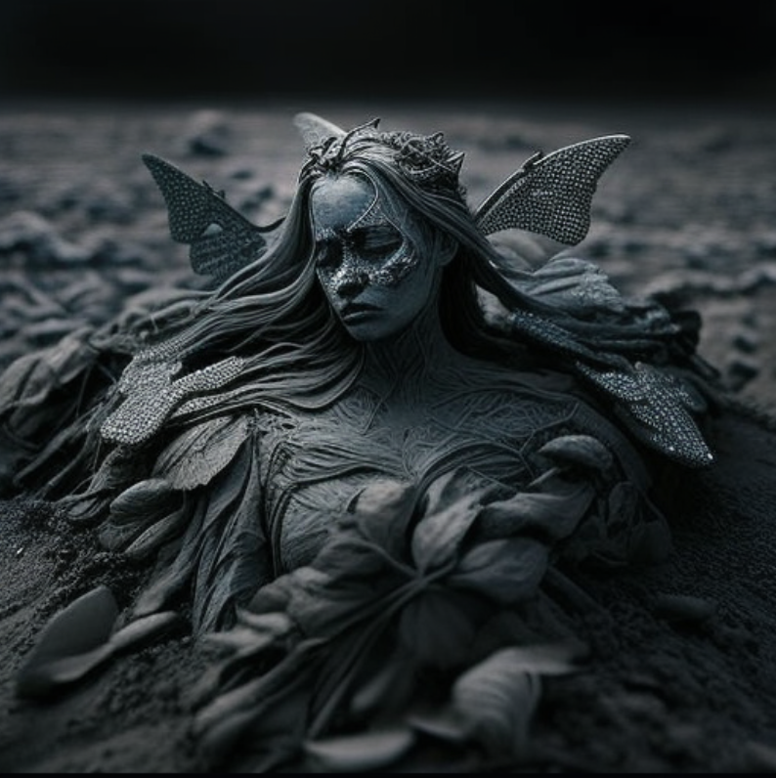

Strolling on the lustrous, slippy terrain for years

Some bore away in the gust of the spell with no spell on her.

Some stayed momentarily, vamoosing shreds of sheer emotions on Her.

Those feelings fled out in the thick storms of ignorance and absence.

There were some, oh! not some but They.

They rambled, footed, bounced, and they dashed on her.

Wondered she, looking at those gnarled footsteps of theirs,

the footsteps on her beige-fluid grounds of the ticker.

Oh, the footsteps trailed the route to the blue acres.

There are blue stomps of somebody.

They are protruding out of her element.

Nevertheless, they are cavernous.

And she said they are whiffs of perfidy.

Blues heeded the red trace.

The hunks of maimed red steps were erratic.

She murmured it's the strength of hate.

Despair, torment, and dread were all tight to the red turf.

Yet, she cruised with the sail.

Black and dead giant stomps shrouded with barren trees,

Desolate land and death-winged butterflies from hell, insensate stems scoring the cloudy tempest.

She fell to her knees, and a wall of water poured down her eyes.

Moulding the obscure clay with her shivering hands and screams,

Wedging the clay, she pinched the tears and fears in her.

Trimming her smile, she dumped it under the sod.

She vacated the puppet for firing and blazing,

an honor for this mortal world to do.

Where was she?

She was on a voyage of her sanity and soul,

Orbiting her past, expanding history to the end.

Belted by the shades of clay, the living puppets,

She went to fetch the mournful clay and horrifying past cause her life was illuming. Either she or the earthlings did not relish her light.

So, she has desired to be the darkest earth of traumas.

Grisly, she is.

-Mahi Verma